Experiment 12
Program for Dimensionality Reduction using PCA

Experiment No. 12

Program for Dimensionality Reduction using PCA

1. Aim
To implement dimensionality reduction using Principal Component Analysis (PCA) and visualize high-dimensional data in reduced dimensions.

2. Objectives
- To understand the concept of dimensionality reduction.
- To study Principal Component Analysis (PCA).
- To reduce high-dimensional data into lower dimensions.
- To visualize transformed data using PCA.
- To analyze variance captured by principal components.

3. Software Required
- Python 3.x
- Jupyter Notebook / Google Colab / Anaconda
- NumPy Library
- Pandas Library
- Scikit-learn Library
- Matplotlib Library

4. Introduction
In machine learning, datasets often contain a large number of features. High-dimensional data increases computational complexity and may contain redundant information.
Dimensionality Reduction is the process of reducing the number of input features while preserving important information from the dataset.
One of the most widely used dimensionality reduction techniques is Principal Component Analysis (PCA).
Machine Learning PCA transforms the original features into a new set of uncorrelated variables called Principal Components. These components capture the maximum variance present in the dataset.

Applications of PCA
Application | Purpose
Image Compression | Reduce image dimensions
Data Visualization | Visualize high-dimensional data
Noise Reduction | Remove less important information
Feature Extraction | Improve model performance

5. Principal Component Analysis (PCA)
Principal Component Analysis is a statistical technique used to reduce the dimensionality of data while preserving maximum variance.

PCA Working Steps
- Standardizing the dataset
- Computing covariance matrix
- Finding eigenvalues and eigenvectors
- Selecting principal components
- Transforming original data into reduced dimensions
The first principal component captures maximum variance, while the second principal component captures the next highest variance and is orthogonal to the first component.

6. Steps in PCA
- Import required libraries
- Load the dataset
- Standardize the dataset
- Apply PCA
- Reduce dimensions
- Visualize transformed data

7. Dataset Description
- The Digits dataset is used in this experiment.
- The dataset contains handwritten digit images represented as numerical pixel values.
- Each image contains 64 features (8 × 8 pixels).
- The objective is to reduce the dataset into 2 principal components for visualization.

Dataset Attributes
Attribute | Description
Pixel Values | Numerical intensity values of image pixels
Digit Label | Actual digit class (0–9)
- Pixel values are independent variables (features).
- Digit labels are used only for visualization.

8. Dataset Characteristics
- Total number of records: 1797
- Number of input features: 64
- Number of classes: 10
- Type of problem: Dimensionality Reduction

9. Learning Objective
The model learns how PCA transforms high-dimensional data into a lower-dimensional representation while preserving maximum variance.
The PCA transformation is represented as:
- 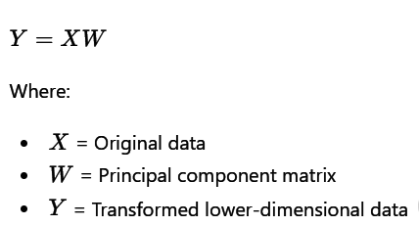

10. Program

import matplotlib.pyplot as plt
from sklearn.datasets import load_digits
from sklearn.decomposition import PCA
from sklearn.preprocessing import StandardScaler

digits = load_digits()

X = digits.data
y = digits.target

scaler = StandardScaler()
X_scaled = scaler.fit_transform(X)
pca = PCA(n_components=2)
X_pca = pca.fit_transform(X_scaled)

print("Original Shape:", X.shape)
print("Reduced Shape:", X_pca.shape)
print("Explained Variance Ratio:")
print(pca.explained_variance_ratio_)

plt.figure(figsize=(8,6))

scatter = plt.scatter(
X_pca[:,0],
X_pca[:,1],
c=y
)

plt.xlabel("Principal Component 1")
plt.ylabel("Principal Component 2")
plt.title("PCA Visualization of High-Dimensional Digits Data")

plt.colorbar(scatter)
plt.show()

Output:
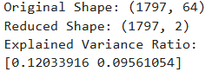
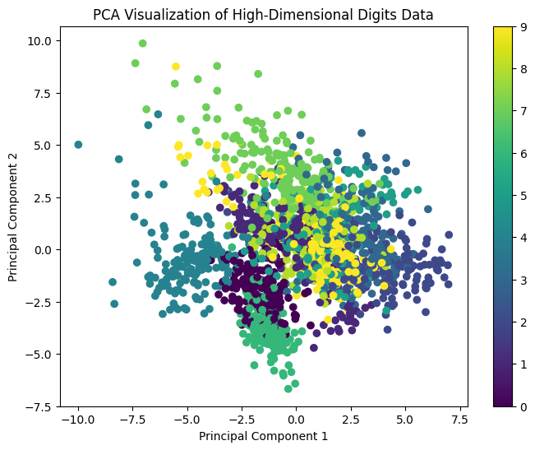

12. Output Explanation
- PCA reduces 64 features into 2 principal components.
- The scatter plot visualizes handwritten digits in 2D space.
- Different colors represent different digit classes.
- The colorbar indicates digit labels from 0 to 9.
- Similar digits form clusters in the graph.

13. Result
The PCA algorithm was successfully implemented to reduce the dimensionality of the Digits dataset from 64 dimensions to 2 dimensions and visualize the transformed data.

14. Conclusion
Principal Component Analysis (PCA) is an effective dimensionality reduction technique used to simplify high-dimensional datasets while preserving important information. PCA helps in visualization, noise reduction, and improving computational efficiency in machine learning applications.

15. Viva Questions

1. What is dimensionality reduction?
Dimensionality reduction is the process of reducing the number of input features in a dataset while preserving important information. It helps reduce computational complexity and remove redundant data.

2. What is PCA?
Machine Learning Principal Component Analysis (PCA) is a statistical technique used to reduce the dimensionality of data while preserving maximum variance.

3. What are principal components?
Principal components are new uncorrelated variables created from the original features. They capture the maximum variance present in the dataset.

4. Why is standardization important before PCA?
Standardization is important because PCA is sensitive to feature scales. It ensures that all features contribute equally to the analysis.

5. What is explained variance ratio?
The explained variance ratio shows how much variance each principal component captures from the original dataset.

6. What is the role of eigenvalues and eigenvectors in PCA?
- Eigenvectors determine the direction of principal components.
- Eigenvalues determine the amount of variance captured by each principal component.

7. What is feature reduction?
Feature reduction is the process of decreasing the number of input variables or features while retaining important information.

8. What are applications of PCA?
Applications of PCA include:
- Image compression
- Data visualization
- Noise reduction
- Feature extraction
- Improving machine learning model performance

9. What is high-dimensional data?
High-dimensional data refers to datasets containing a large number of features or variables.
Example:
A dataset with 64 or more features is considered high-dimensional data.

10. Why is PCA useful in machine learning?
PCA is useful because it:
- Reduces computational complexity
- Removes redundant information
- Improves visualization
- Reduces noise
- Improves model performance and efficiency

